

Creating New Galleries
Traditional Gallery

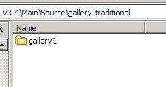

Copy the folder called gallery1 and paste it, name it whatever you want. Let’s just assume we’re going to call it portraits.

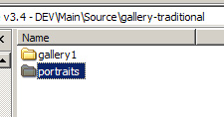

Open the portraits folder. This is where you’ll put in your videos and images for this particular gallery.

You’ll need to edit main.fla for one quick change. Open main.fla in that folder.

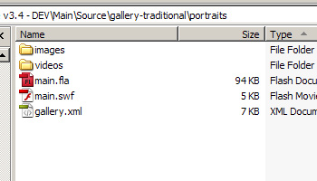

Open the Actions layer of main.fla and find line 24: Change it to the following.

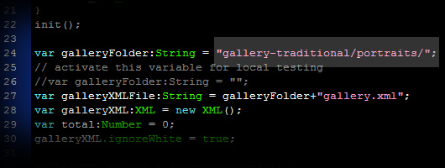

Now we need to link it. This is a good time to take advantage to the submenu feature to have real working categories. This is done to either your submenu.xml or navigation.xml. For the sake of simplicity, lets use navigation.xml.

Give it the proper name, I’ve called it Portraits Gallery. More importantly, change <asset> like below.

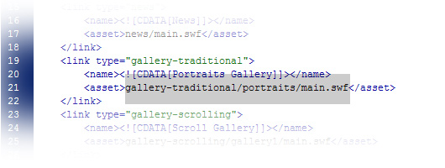

You’re done!

Scrolling Gallery

Ok, we’re going to do the same thing for the scrolling gallery. Same process. Navigate to the “gallery-scrolling” folder, make a copy of gallery1 and name it whatever you want, I’ve called it gallery2.

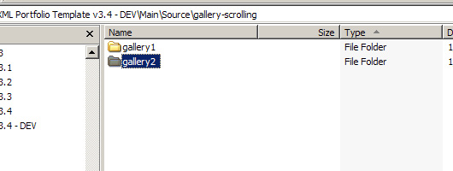

Open gallery2

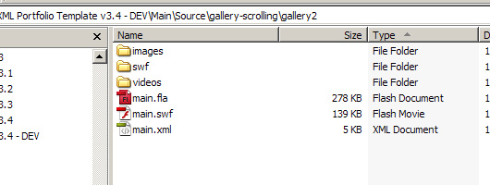

Go ahead and give it new images and videos and whatever else you need.

Open main.fla.

Edit just like the following:

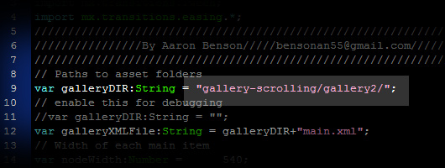

Now link it in either a submenu or navigation.xml.

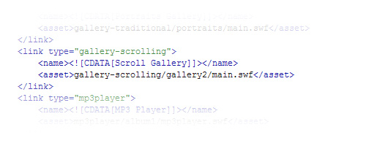
It’s the same process for the mp3 gallery. The other modules can be made in the same way. Happy modding!
-Aaron

